(LECTURE #3 ON REGRESSION ANALYSIS)
BRIEF REVIEW
In Lecture 1 we considered the simple linear model
Y = β₀ + β₁X + E,
and showed how it could be fitted using least squares.
In Lecture 2, assuming independence, normality, and homoscedasticity, we found the distributions of $\hat{σ^{2}}$, $\hat{β_{1}}$, and $\hat{β_{0}}$+$\hat{β_{1}}$X, and thence various inference procedures.

Today we shall consider in more detail
Pearson's product-moment correlation coefficient

r = | $$\frac{Σ(X_{i}−\bar{X})(Y_{i}−\bar{Y})}{\sqrt{Σ(X_{i}−\bar{X})^{2}}\sqrt{Σ(Y_{i}−\bar{Y})^{2}}}$$

In a regression context, this is the correlation between the observed and fitted values. But in general, this standard formula is unintuitive. We do know that

r² = 1 ⇔ SSE = Σ$R_{i}^{2}$ = 0
which happens only if all the data fall exactly on a line
(of positive slope if r = + 1 or negative if r = – 1.)

But the best way to gain an intuition
about smaller values of r²
may be to calibrate our eyes to some examples.
“CORRELATION MADE VISIBLE”
(Moore, Statistics: Concepts & Controversies)
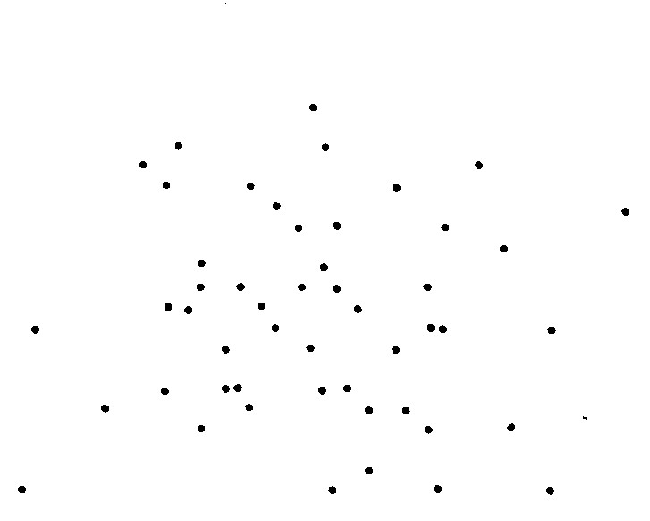 | 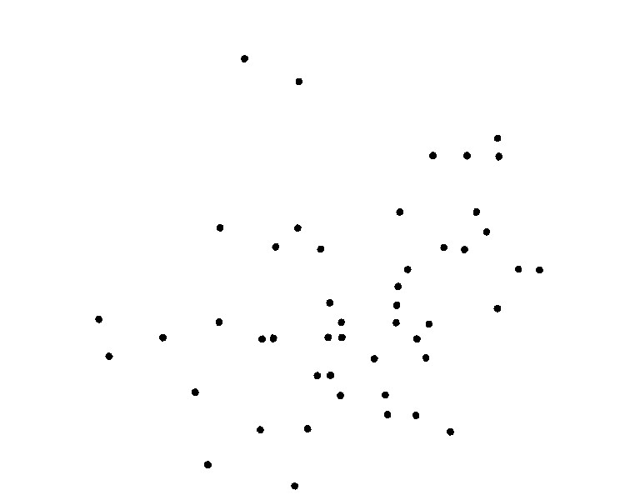
r = 0.01 | r = 0.28
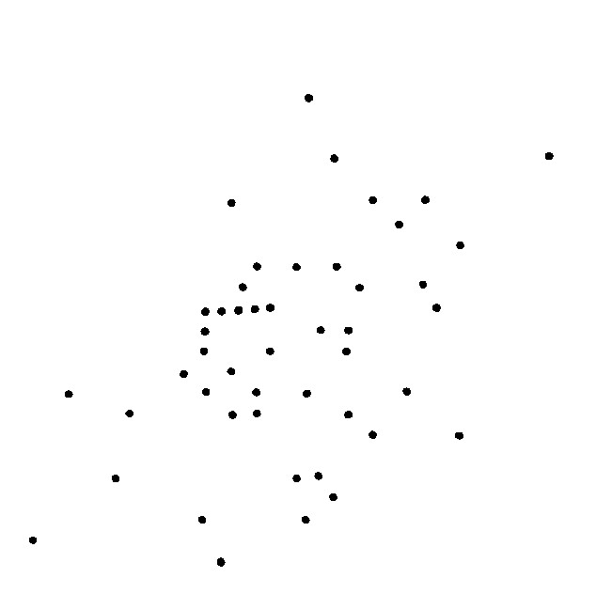 | 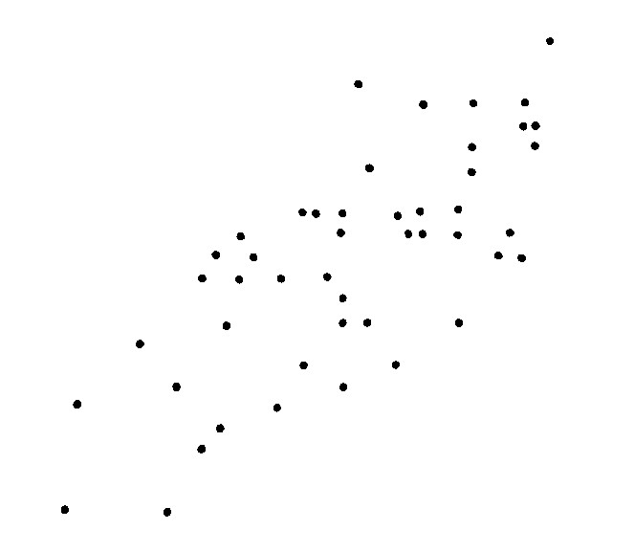
r = 0.43 | r = 0.73
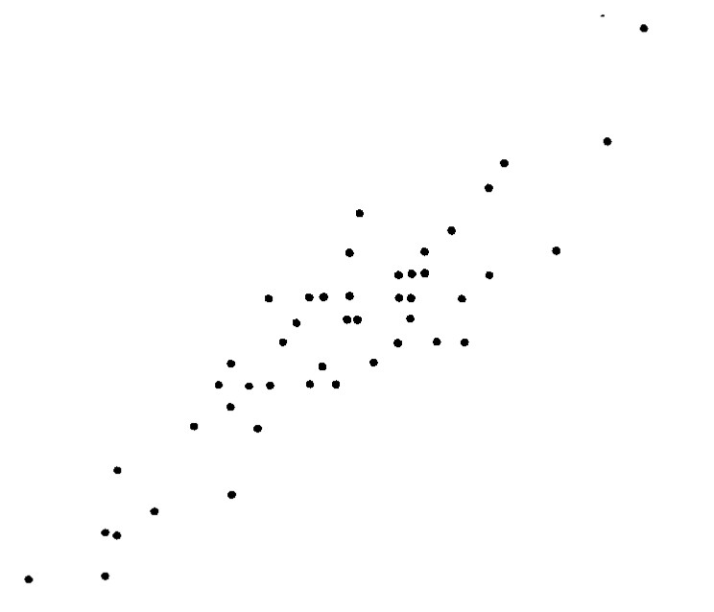 | 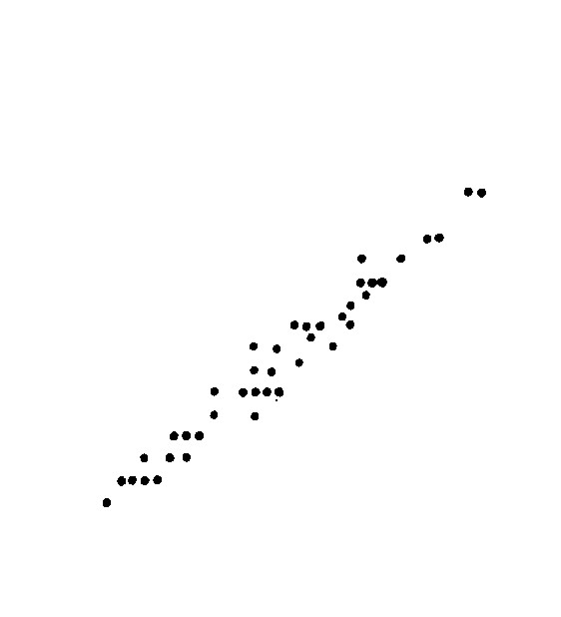
r = 0.91 | r = 0.99

What about Galton's data?
TESTING FOR ZERO CORRELATION

We know that ρ = 0 if and only if β₁ = 0.

If β₁ = 0 then $\frac{\hat{β_{1}}\sqrt{ S_{\text{xx}}}}{\sqrt{ \text{SSM/}(n−2)}}$ ~ t(n - 2).

But $\hat{β_{1}}$ = $\frac{Σ(X_{i}−\bar{X})(Y_{i}−\bar{Y})}{Σ(X_{i}−\bar{X})^{2}}$ = $\frac{r\sqrt{Σ(Y_{i}−\bar{Y})^{2}}}{\sqrt{Σ(X_{i}−\bar{X})^{2}}}$ = $\frac{r\sqrt{ S_{\text{yy}}}}{\sqrt{ S_{\text{xx}}}}$
Thus
$\frac{\hat{β_{1}}\sqrt{ S_{\text{xx}}}}{\sqrt{ \text{SSM/}(n−2)}}$ = $\frac{r\sqrt{ S_{\text{yy}}}}{\sqrt{ S_{\text{xx}}}}$ × $\frac{\sqrt{ S_{\text{xx}}}\sqrt{n−2}}{\sqrt{ \text{SSM-SSE}}}$

= $\frac{r\sqrt{n−2}}{\sqrt{ {\text{1-r}}^{2}}}$ ~ t(n - 2)

For Galton's data we had n = 12, r = .703, so

$\frac{r\sqrt{n−2}}{\sqrt{ {\text{1-r}}^{2}}}$ = $\frac{\text{.}\text{703}\sqrt{\text{10}}}{\sqrt{ \text{1-}(\text{.}\text{703})^{2}}}$ = 3.12 (as before)

But this doesn't help us test

H_{o}: ρ = ρ_{o} if ρ_{o} ≠ 0 .
DISTRIBUTION OF R

The population value of the correlation r is
ρ = σ_{XY} / σ_{X} σ_{Y}
and r is a consistent estimator of this parameter.
The distribution of r extends from –1 to +1,
skewed (unless ρ = 0), and is quite complicated.

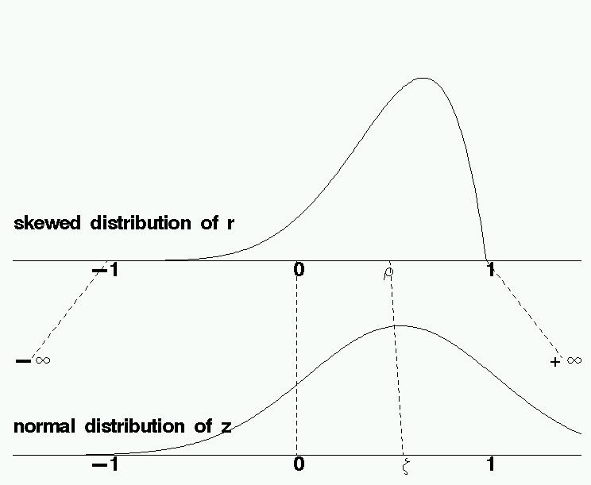

Fisher derived the “z-transformation” of r :

Z = tanh⁻¹(r) = $\frac{1}{2}{\text{log}}_{e}\left(\frac{1+r}{1−r}\right)$  N$\left\{ζ, \frac{1}{n−3}\right\}$,

where ζ = tanh⁻¹(ρ) = $\frac{1}{2}{\text{log}}_{e}\left(\frac{1+ρ}{1−ρ}\right)$ .
This normal approximation is particularly convenient
since its variance does not depend on the value of ρ.
CONFIDENCE INTERVAL ON RHO

To obtain a confidence interval on ρ,
form an interval for ζ, then transform back,
using ρ = tanh(ζ) = $\frac{e^{\text{2ζ}}−1}{e^{\text{2ζ}}+1}$ .

$$\left[\frac{1}{2}\text{ln} \left(\frac{1+r}{1−r}\right) − \frac{Z^{}}{\sqrt{ n−3}}\right] ≤ ζ ≤ \left[\frac{1}{2}\text{ln} \left(\frac{1+r}{1−r}\right) + \frac{Z^{}}{\sqrt{ n−3}}\right]$$

tanh[ ] ≤ ρ ≤ tanh[ ]

EXAMPLE:
For Galton's data, with n = 12 and r = .703,

$\frac{1}{2}\text{ln} \left(\frac{1+r}{1−r}\right)$ = .8725 and Z* = 1.96 if α = .05,
so
.8725 – 1.96/$\sqrt{9}$ ≤ ζ ≤ .8725 + 1.96/$\sqrt{9}$
.8725 – .6533 ≤ ζ ≤ .8725 + .6533
.2192 ≤ ζ ≤ 1.5258
tanh(.2192) ≤ ρ ≤ tanh(1.5258)
.216 ≤ ρ ≤ .910

This also says that values of ρ between .216 and .910 would be accepted at 5% if tested,
while other values would be rejected.
WHAT IS “PERFECT” CORRELATION?

Consider Galileo's data again.

Height in “points” 1000 828 800 600 300
Horizontal distance 1500 1340 1328 1172 800
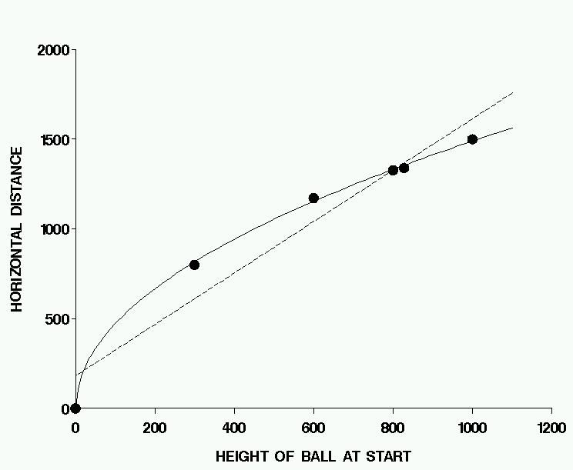

I have added another point, at (0,0).
Galileo didn't do this, but he certainly could have.
Now r = .967 (it was .994 without the added point).

But D is related to H by a physical law: D = H .
(The constant is estimated from the data to be 47.)
If correlation measures the strength of this relationship, why is its value not equal to 1, the maximum possible?
SPEARMAN'S RANK CORRELATION

Convert the data to ranks:
let T_{i} be the rank of X_{i} and U_{i} the rank of Y_{i} .
Then correlate the ranks, obtaining

r_{S} = | $$\frac{Σ(T_{i}−\bar{T})(U_{i}−\bar{U})}{\sqrt{Σ(T_{i}−\bar{X})^{2}Σ(U_{i}−\bar{U})^{2}}}$$

If the ranks are (T,U) = (1,1), ..., (n,n)
then U = 0 + 1  T and r_{S} = + 1
If the ranks are (T,U) = (1,n), ..., (n,1)
then U = (n+1)  1  T and r_{S} =  1

For “well-behaved” data, r and r_{S} are about the same,
but Spearman’s correlation is much less affected
by outliers than Pearson’s.

For Galileo's data, with or without (0,0), r_{S} = 1.

For Galton's data, we have

X 62 63 64 65 66 67 67 68 68 69 70 71
Y 66 66 65 68 65 67 68 69 71 68 68 70

T 1 2 3 4 5 6.5 6.5 8.5 8.5 10 11 12
U 3.5 3.5 1.5 7.5 1.5 5 7.5 10 12 7.5 7.5 11

r = .70 r_{S} = .74

Tests and confidence intervals for r_{S} are obtained
just as for r, if n is reasonably large (at least 10, say).
THE D² FORMULA

$\bar{T}$ = $\bar{U}$ = $\frac{(n+1)}{2}$
and (if there are no ties) $T_{i}^{2}$ = $U_{i}^{2}$ = $\frac{n(n+1)(\text{2n}+1)}{6}$

so  (T_{i}  $\bar{T}$)² = $T_{i}^{2}$  n$\bar{T}$²

= $\frac{n(n+1)(\text{2n}+1)}{6}$  n($\frac{(n+1)}{2}$)² = $\frac{n(n+1)(n−1)}{\text{12}}$ .

Now consider $D_{i}^{2}$, where D_{i} = T_{i}  U_{i} .

$D_{i}^{2}$ =  (T_{i}U_{i})²

= ( (T_{i}$\bar{T}$)  (U_{i}$\bar{U}$) )² ( since $\bar{T}$ = $\bar{U}$ )

= (T_{i} $\bar{T}$)²  2(T_{i}$\bar{T}$)(U_{i}$\bar{U}$) + (U_{i}$\bar{U}$)²

= (n³n)/6  2(T_{i}$\bar{T}$)(U_{i}$\bar{U}$) ,
so
(T_{i}$\bar{T}$)(U_{i}$\bar{U}$) = (n³n)/12  $D_{i}^{2}$/2 .

Then $r_{S} = \frac{(n^{3}−n)\text{/12} − {\text{ΣD}}_{i}^{2}\text{/2}}{(n^{3}−n)\text{/12}} =$ $1 − \frac{6{\text{ΣD}}_{i}^{2}}{n^{3}−n}$.

However, this formula is incorrect if there are ties.
Then we should use “average ranks”
with the ordinary correlation formula.

