(LECTURE #2 ON REGRESSION ANALYSIS)
FORMAL INFERENCE - ASSUMPTIONS

Lecture #1 considered regression descriptively.
We discussed the simple linear model Y = ₀+ ₁X + E,
showed how it could be fitted using least squares,
and related it to correlation.
We assumed only “existence” – that Y_{i} | X_{i} has a mean.

Now suppose we want to test a hypothesis
e.g., that ₁ = 0, or that µ[Y] = 3 for X = 10
or obtain a confidence interval for some parameter,
such as ₀ or ₁, or even (₀ + 3₁).
This means finding P-values or confidence coefficients
(which are probabilities), so we need to make some assumptions. Specifically, we shall assume:

A) INDEPENDENCE: Y₁, ..., Y_{n}, given the Xs,
are mutually independent (or, equivalently,
E₁, ..., E_{n} are mutually independent).

B) NORMALITY: Y_{i}|X_{i} is normally distributed
(with mean µ_{i} = µ[Y_{i}|X_{i}] and
variance $σ_{i}^{2}$ = σ²[Y_{i}|X_{i}] ).

C) HOMOSCEDASTICITY: $σ_{1}^{2}$ = ... = $σ_{n}^{2}$ (= σ²).
MAXIMUM LIKELIHOOD ESTIMATES

The distribution of Y_{i} given X_{i} is N{β₀+₁X_{i}, σ²}.

Hence the likelihood function of the sample of Ys is
L(₀, ₁, σ) = | n  Π  i=1 | $$[\frac{1}{σ\sqrt{\text{2π}}}e^{− \frac{(Y_{i}−β_{0}−β_{1}X_{i})^{2}}{{\text{2σ}}^{2}}}]$$

We want to find the ₀, ₁, and σ that maximize this.

ln[L] =$−\frac{1}{{\text{2σ}}^{2}}$$\sum_{i=1}^{n}{}$(Y_{i} – ₀ – ₁X_{i})² – n ln(σ$\sqrt{\text{2π}}$).
No matter what σ is, we maximize ln[L] by choosing
β₀ and ₁ to minimize the sum of squares: i.e., the maximum likelihood estimates of ₀ and ₁ are the same as the least-squares estimates. The minimum sum of squares is then ΣR² and we have
ln[L] = $−\frac{1}{{\text{2σ}}^{2}}$ΣR² – n ln(σ) – n ln($\sqrt{\text{2π}}$).

To estimate σ we set
d ln[L] / d σ = ($\frac{{ΣR}^{2}}{σ^{3}}$ – $\frac{n}{σ}$ – 0) equal to 0 .
Solving for σ produces σ² = ΣR²/n,
but it can be shown that this is a biased estimate,
so we replace it by the unbiased estimate

$\hat{σ^{2}} = \frac{{ΣR}^{2}}{n−2}$ , which we call $S_{Y|X}^{2}$.
DISTRIBUTION OF ESTIMATED VARIANCE

Recall that for Y₁, ..., Y_{n} independent N{µ, σ²}

( i.e., Y_{i} ~ N{µ, σ²} )
we have
µ[$\frac{Σ(Y_{i}−\bar{Y})^{2}}{n−1}$] = σ² and $\hat{σ^{2}}$ = $\frac{Σ(Y_{i}−\bar{Y})^{2}}{n−1}$ ,
and
$\frac{Σ(Y_{i}−\bar{Y})^{2}}{σ^{2}}$ ~ χ²(n-1), independent of $\hat{μ}$ = $\bar{Y}$ .

By a similar (but more complicated) argument, if

Y_{i} | X_{i} ~ N{₀ + ₁X_{i}, σ²}
then
µ[$\frac{Σ(Y_{i}−{\hat{Y}}_{i})^{2}}{n−2}$] = σ² and $\hat{σ^{2}}$ = $\frac{Σ(Y_{i}−{\hat{Y}}_{i})^{2}}{n−2}$ ,
and
$\frac{Σ(Y_{i}−{\hat{Y}}_{i})^{2}}{σ^{2}} = \frac{\text{SSE}}{σ^{2}} = \frac{(n−2)S_{Y|X}^{2}}{σ^{2}}$ ~ χ²(n-2),

independent of $\hat{β_{0}}$ and $\hat{β_{1}}$.

There are n-2 degrees of freedom, where the 2
corresponds to 2 parameters being estimated.

For Galton's data, $\hat{σ^{2}} = S_{Y|X}^{2} = \frac{\text{19}\text{.}\text{703}}{\text{10}} = 1\text{.}\text{9703}$.
LINEAR FUNCTIONS OF VARIABLES

Given variables Y₁, ..., Y_{n} and constants h₁, ..., h_{n},
the variable
Z = h₁Y₁+ ... + h_{n}Y_{n} = Σ h_{i}Y_{i}

is called a “linear function”, or “linear combination”,
of the Ys.

1) If Y_{i} has mean µ_{i} for i = 1, ..., n,
then the expectation of Z is

µ[Z] = Σ h_{i} µ_{i} .

2) If Y_{i} has variance $σ_{i}^{2}$
and Y_{i} and Y_{j} have correlation ρ_{ij},
then the variance of Z is

σ²[Z] = Σ$h_{i}^{2}$$σ_{i}^{2}$ + | Σ h_{i} h_{j} ρ_{ij}σ_{i}σ_{j}  i≠j

(If the Ys are uncorrelated,
the second summation vanishes.)

3) If the Ys are independent and normally distributed,
then Z is normally distributed.
DISTRIBUTION OF ESTIMATED SLOPE

$\hat{β_{1}}$ = $\frac{Σ(X_{i}−\bar{X})(Y_{i}−\bar{Y})}{Σ(X_{i}−\bar{X})^{2}}$

Write $Σ(X_{i}−\bar{X})^{2}$ = S_{xx} (cf S_{yy})

$\hat{β_{1}}$ =$\frac{1}{S_{\text{xx}}}$[Σ(X_{i}-$\bar{X}$)Y_{i} – Σ(X_{i}-$\bar{X}$)$\bar{Y}$]
= Σh_{i}Y_{i} where h_{i} = $\frac{(X_{i}−\bar{X})}{S_{\text{xx}}}$

Thus $\hat{β_{1}}$ is a linear function of independent Ys.
 | Σh_{i} | = | $$\sum{\frac{(X_{i}−\bar{X})}{S_{\text{xx}}}}$$ | = | 0
Note that | Σ$h_{\text{ i}}^{2}$ | = | $$\sum{\frac{(X_{i}−\bar{X})^{2}}{S_{\text{xx}}^{2}}}$$ | = | $$\frac{1}{S_{\text{xx}}}$$
 | Σh_{i}X_{i} | = | $$\sum{\frac{(X_{i}−\bar{X})X_{i}}{S_{\text{xx}}}}$$ | = | $$\frac{Σ(X_{i}−\bar{X})(X_{i}−\bar{X})}{S_{\text{xx}}}$$ | = 1

µ[$\hat{β_{1}}$] = Σ h_{i} µ[Y_{i}]
= Σh_{i} (β₀ + ₁X_{i})

= β₀ Σh_{i} + ₁Σh_{i}X_{i} = ₁

σ²[$\hat{β_{1}}$] = Σ$h_{\text{ i}}^{2}$σ²[Y_{i}] = σ²Σ$h_{\text{ i}}^{2}$ = $\frac{σ^{2}}{S_{\text{xx}}}$

So $\hat{β_{1}}$ ~ N{₁, $\frac{σ^{2}}{S_{\text{xx}}}$}
(implications for design)
INFERENCE ON THE SLOPE

We have found that

$\hat{β_{1}}$ = $\frac{Σ(X_{i}−\bar{X})(Y_{i}−\bar{Y})}{Σ(X_{i}−\bar{X})^{2}}$ ~ N{₁, $\frac{σ^{2}}{S_{\text{xx}}}$}

so $\frac{\hat{β_{1}}−β_{1}}{\sqrt{\frac{σ^{2}}{S_{\text{xx}}}}} = \frac{({\hat{β}}_{1}−β_{1})\sqrt{S_{\text{xx}}}}{σ}$ ~ Z ( i.e., N{0,1} )

and $\frac{(n−2)S_{Y|X}^{2}}{σ^{2}}$ ~ χ²(n-2) independent of $\hat{β_{1}}$.
so $\sqrt{\frac{(n−2)S_{Y|X}^{2}}{σ^{2}(n−2)}}$ = $\frac{S_{Y|X}}{σ}$ ~ $\sqrt{\frac{χ^{2}}{\text{DF}}}$

Thus | $$\frac{({\hat{β}}_{1}−β_{1})\sqrt{S_{\text{xx}}}}{σ}$$ | / | $\frac{S_{Y|X}}{σ} =$$\frac{({\hat{β}}_{1}−β_{1})\sqrt{S_{\text{xx}}}}{S_{Y|X}}$ ~ t(n - 2).

Thus, to test the hypothesis that ₁ = (say) $β_{1}^{}$ :
let $\frac{({\hat{β}}_{1}−β_{1}^{})\sqrt{S_{\text{xx}}}}{S_{Y|X}}$ ~ t(n - 2)
To place a (100–α)% confidence interval on ₁:

let $t_{α}^{}$ be the critical value for t(n - 2)
then the margin of error is MOE = $\frac{t_{α}^{}S_{Y|X}}{\sqrt{S_{\text{xx}}}}$
and the interval is $\hat{β_{1}}$ ± MOE .
EXAMPLES: GALTON'S DATA

1) Are sons' heights related to (or “correlated with”) fathers' heights? Test H₀: ₁ = 0.

$\frac{({\hat{β}}_{1}−0)\sqrt{S_{\text{xx}}}}{S_{Y|X}}$ = $\frac{(0\text{.}\text{476}−0)\sqrt{\text{84}\text{.}\text{67}}}{\sqrt{1\text{.}\text{97034}}}$ = 3.12
Taking this as t(10), the 2-sided P-value is 0.0108 .

2) Test H₀: ₁ = 1.

$\frac{({\hat{β}}_{1}−1)\sqrt{S_{\text{xx}}}}{S_{Y|X}}$ = $\frac{(0\text{.}\text{476}−1)\sqrt{\text{84}\text{.}\text{67}}}{\sqrt{1\text{.}\text{97034}}}$ = – 3.43
Taking this also as t(10), the 2-sided P-value is .0064

3) What values of ₁ would be accepted at 5%?
The two-sided 5% critical value for t(10) is t = 2.228,
so the margin of error for ₁ is
MOE = $\frac{t_{α}^{}S_{Y|X}}{\sqrt{S_{\text{xx}}}}$ = $\frac{2\text{.}\text{228}\sqrt{1\text{.}\text{9703}}}{\sqrt{\text{84}\text{.}\text{667}}}$ = .340 .
The confidence interval is .476 ± .340 or (.136, .816).
Interpretation: We are 95% confident that the slope is between .136 and .816: i.e., if a father is 1" taller than another father, his eldest son will be between .136 and .816 inches taller than the other father's eldest son.
Or, values between .136 and .816 would be accepted
at level 5% if hypothesized for ₁.
DISTRIBUTION OF THE VALUE OF $\hat{β_{0}}$ + $\hat{β_{1}}$X
Note: Distinguish X from $\bar{X}$ from X_{i} !

$\hat{β_{0}}$ + $\hat{β_{1}}$X = ($\bar{Y}$ – $\hat{β_{1}}$$\bar{X}$) + $\hat{β_{1}}$X

= $\bar{Y}$ + $\hat{β_{1}}$ (X–$\bar{X}$)

= ΣY_{i} ( $\frac{1}{n}$ + (X–$\bar{X}$) h_{i} )

This is a linear function of the Ys. The Ys are normal and independent so the linear function is normal.

Clearly µ[ $\hat{β_{0}}$ + $\hat{β_{1}}$X ] = µ[$\hat{β_{0}}$] + Xµ[$\hat{β_{1}}$]

= ₀ + ₁X
and
σ²[$\hat{β_{0}}$ + $\hat{β_{1}}$X]

= σ²[ΣY_{i} ( $\frac{1}{n}$ + (X–$\bar{X}$) h_{i} )]
= σ²Σ($\frac{1}{n}$ + (X–$\bar{X}$) h_{i} )²

= σ²(Σ$\frac{1}{n^{2}}$ + Σ$\frac{2}{n}$ (X–$\bar{X}$) h_{i} + Σ (X–$\bar{X}$)²$h_{\text{ i}}^{2}$
= σ² ($\frac{1}{n}$ + 0 + $\frac{(X−\bar{X})^{2}}{S_{\text{xx}}}$

so $\hat{β_{0}}$ + $\hat{β_{1}}$X ~ N{ ₀ + ₁X, σ²($\frac{1}{n}$ + $\frac{(X−\bar{X})^{2}}{S_{\text{xx}}}$) }
INFERENCE ON THE VALUE OF ₀ + ₁X

The preceding result allows us to state
a confidence interval for ₀ + ₁X,
i.e., for the mean response Y at any value of X.

We have $\frac{({\hat{β}}_{0}+{\hat{β}}_{1}X)−(β_{0}+β_{1}X)}{\sqrt{σ^{2}(\frac{1}{n}+\frac{(X−\bar{X})^{2}}{S_{\text{xx}}})}}$ | / | $\frac{S_{Y|X}}{σ}$ ~ t(n-2)

Let $t_{α}^{}$ be the critical value for t(n - 2);

then MOE = $t_{α}^{}$S_{Y|X}$\sqrt{\frac{1}{n}+\frac{(X−\bar{X})^{2}}{S_{\text{xx}}}}$ ,

and the interval is $\hat{β_{0}}$ + $\hat{β_{1}}$X ± MOE .

EXAMPLE: Galton's data
Suppose we want a 95% confidence interval for
the mean height of sons whose fathers are 70" tall.

The estimated mean is 35.824 + .476 × 70 = 69.14"

The MOE is 2.228$\sqrt{1\text{.}\text{9703}}$$\sqrt{\frac{1}{\text{12}}+\frac{(\text{70}−\text{67}\text{.}\text{583})^{2}}{\text{84}\text{.}\text{667}}}$ = 1.22"

The interval is 69.14" ± 1.22", or (67.92", 70.36")

The special case where X = 0
yields inference on the intercept.
(For Galton's data, of course, this is not meaningful.)
CONFIDENCE BAND

The curves formed by the intervals
at various values of X
form a “confidence band”
for the regression function.

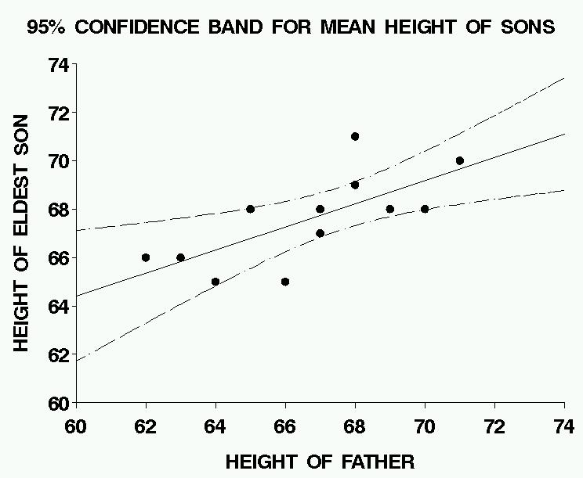
PREDICTION

Suppose we want to predict the value of Y
for a NEW observation at some value of X.

The true value will be Y = ₀ + ₁X + E .

The predicted value will be $\bar{Y}$ = $\hat{β_{0}}$ + $\hat{β_{1}}$X .

The prediction error will be

$\bar{Y}$ – Y = ($\hat{β_{0}}$ + $\hat{β_{1}}$X) – ( ₀ + ₁X ) – E

with mean 0 and variance

σ²($\frac{1}{n}$ + $\frac{(X−\bar{X})^{2}}{S_{\text{xx}}}$) + 0 + σ²
= σ²(1 + $\frac{1}{n}$ + $\frac{(X−\bar{X})^{2}}{S_{\text{xx}}}$) .
↑
Note the extra variation in the prediction,
added by the new observation.

A “prediction interval” can then be found,
like the confidence interval for the mean response, and a corresponding “prediction band”,
which will be much wider than the confidence band.

GALTON'S DATA: PREDICTION BANDS
AND CONFIDENCE BANDS COMPARED
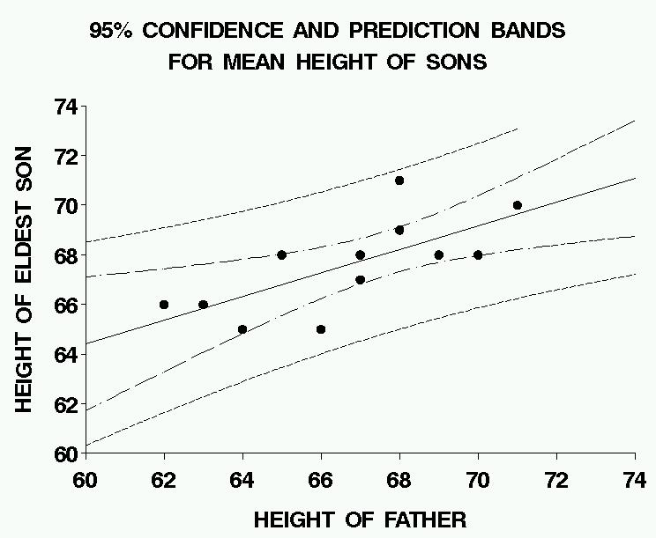

If the assumptions are satisfied,
then, for any specified value of X,
the (narrow) confidence band includes
the value of the regression function
with 95% probability,
while the (wide) prediction band will include
95% of all new observations.
COMPUTER OUTPUT (“SAS”) with
ANALYSIS OF VARIANCE TABLE

The REG Procedure
Model: MODEL1
Dependent Variable: SON

Analysis of Variance

Sum of Mean
Source DF Squares Square F Value Pr > F

Model 1 19.21391 19.21391 9.75 0.0108
Error 10 19.70276 1.97028
Corrected Total 11 38.91667

Root MSE 1.40367 R-Square 0.4937
Dependent Mean 67.58333 Adj R-Sq 0.4431
Coeff Var 2.07694

Parameter Estimates

Parameter Standard
Variable DF Estimate Error t Value Pr > |t|

Intercept 1 35.82480 10.17795 3.52 0.0055
FATHER 1 0.47638 0.15255 3.12 0.0108

