(LECTURE #1)
REGRESSION ANALYSIS

RELATIONSHIP BETWEEN VARIABLES
(say, X and Y)

VARIABLES

X EXPLANATORY (or “INDEPENDENT”)

Y RESPONSE (or “DEPENDENT”)

Y ≈ f(X)

A FORMULA
for estimating or predicting Y given X ( Y | X )
or explaining Y in terms of X

compare with
CORRELATION ANALYSIS
SYMMETRIC: C(X,Y) = C(Y,X)
measures STRENGTH of relationship
(but provides no formula)
TERMINOLOGY

simple regression Y | X
multiple regression Y | X1, X2, ..., Xm
multivariate regression Y1, Y2, ..., Ym | X
(multivariate multiple regression etc)

MODEL: µ[Y] = f(X) REGRESSION FUNCTION
(deterministic part of Y)

Y = f(X) + E “ERROR” (deviation or “miss”)
where µ[E] = 0 by definition

LINEAR IN X

Y = ₀(  1) + ₁X + E
✴ 
intercept slope (parameters)

LINEAR IN PARAMETERS

(1) Y = ₀ + ₁X + ₂X² + E “quadratic in X”

(2) Y = X + E (illustrated by next transparency)

= “GENERAL LINEAR MODEL”
GALILEO'S DATA finding a physical law
(Dickey & Arnold, J Stat Ed v3n1, 1995)
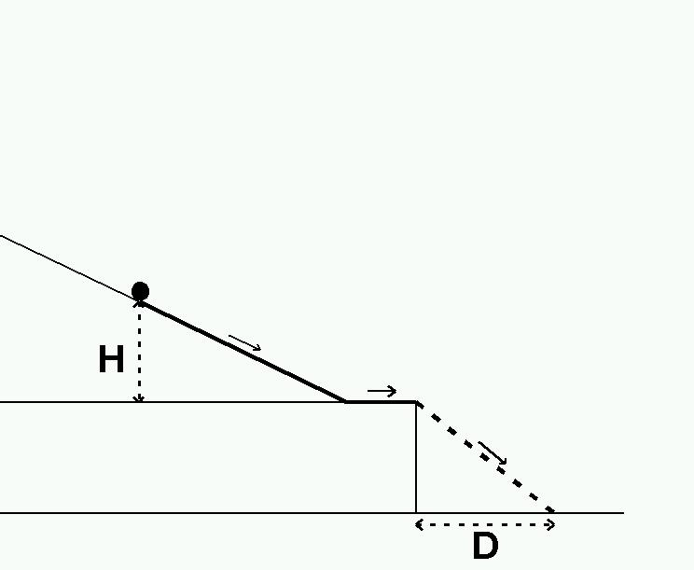
Height in “points” 1000 828 800 600 300
Horizontal distance 1500 1340 1328 1172 800

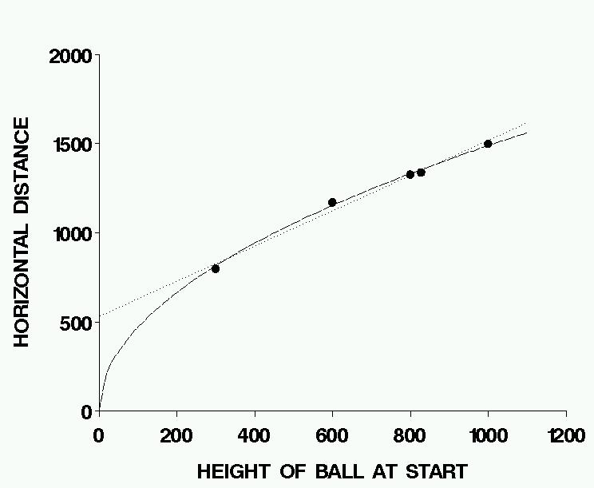

Model: D = ₀ + ₁H + E or D = H + E ?

(either way, it's a “linear model”)
GALTON'S DATA

Heights (in.) of fathers (X) and their eldest sons (Y)

Family # 1 2 3 4 5 6 7 8 9 10 11 12
X 62 63 64 65 66 67 67 68 68 69 70 71
Y 66 66 65 68 65 67 68 69 71 68 68 70

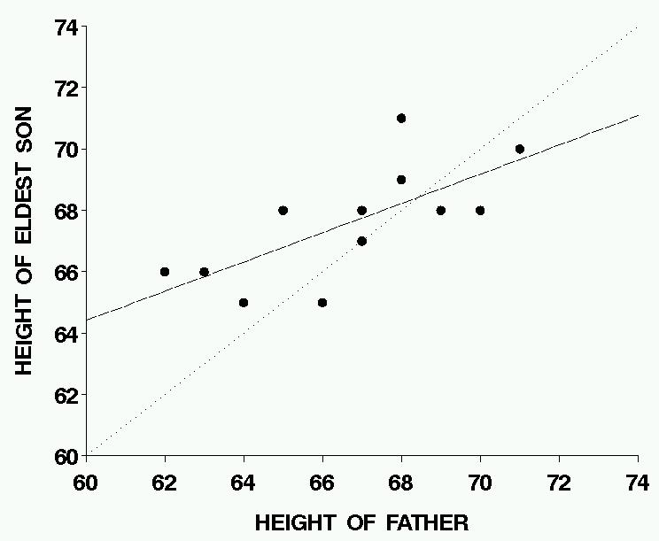

“REGRESSION TO THE MEAN”
ESTIMATION BY LEAST SQUARES

Suppose we fit a model to the data, say

$\hat{μ}$[Y] = $\hat{f}$(X)

Check the fit at the observed values of (X,Y): let

$\hat{Y_{i}}$ = $\hat{f}$(X_{i}) for i = 1, ..., n FITTED VALUES
and
R_{i} = $\hat{Y_{i}}$Y_{i} for i = 1, ..., n RESIDUALS
(the amounts by which the fitted function
misses the observed values of Y)

Clearly we want the residuals to be small.
The PRINCIPLE OF LEAST SQUARES
says that the estimate should be chosen
to make the SUM of SQUARED residuals
as small as possible: i.e., to minimize Σ$R_{i}^{2}$.

We shall see that this is not difficult
IF our model is linear (in the parameters),
although for simplicity we give details
only for the simple linear (in X) model:

Y = ₀ + ₁X + E
EXAMPLE: GALTON’S DATA

f(X) + E = Y = $\hat{f}$(X) + R

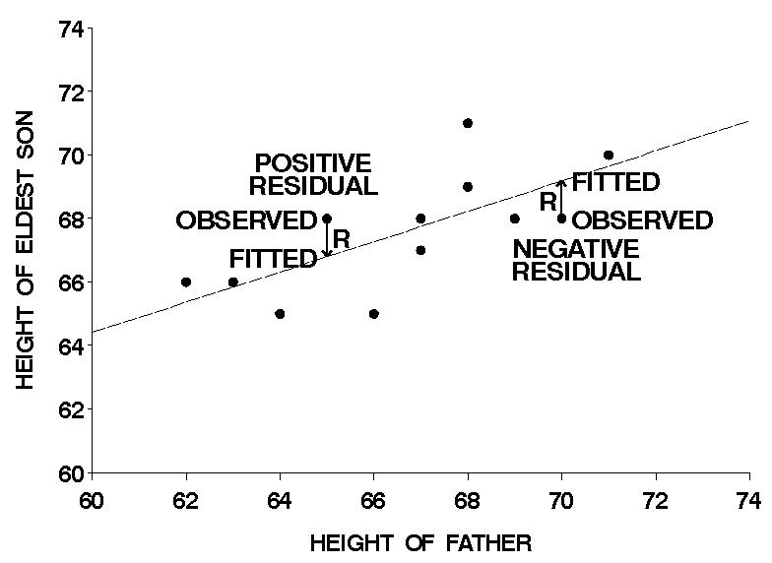

RESIDUAL = OBSERVED – FITTED
LEAST-SQUARES COMPUTATIONS

$R_{i}^{2}$  $(Y_{i}−{\hat{Y}}_{i})^{2}$  $(Y_{i}−{\hat{β}}_{0}−{\hat{β}}_{1}X_{i})^{2}$

To find the $\hat{β_{0}}$ and $\hat{β_{1}}$ that minimize this,
set the partial derivatives equal to zero.

/₀:  2 $(Y_{i}−{\hat{β}}_{0}−{\hat{β}}_{1}X_{i})$ (1) = 0
/₁:  2 $(Y_{i}−{\hat{β}}_{0}−{\hat{β}}_{1}X_{i})$ (X_{i}) = 0

“normal equations”
 $Y_{i}$ = n $\hat{β_{0}}$ + $\hat{β_{1}}$ X_{i}
 X_{i}Y_{i} = $\hat{β_{0}}$ X_{i} + $\hat{β_{1}}$ $X_{i}^{2}$

Solution (page 7 of notes, Section 11.3 of text)
$\hat{β_{0}}$ = $\bar{Y}−$ $\hat{β_{1}}$ $\bar{X}$,
$\hat{β_{1}}$ = $\frac{Σ(X_{i}−\bar{X})(Y_{i}−\bar{Y})}{Σ(X_{i}−\bar{X})^{2}}$ ,
and $\hat{Y_{i}}$ = $\hat{β_{0}}$ + $\hat{β_{1}}$ X_{i} .
Note:

1) If X = $\bar{X}$ then $\hat{Y}$ = ($\bar{Y}−$$\hat{β_{1}}$$\bar{X}$) + $\hat{β_{1}}$$\bar{X}$ = $\bar{Y}$:
i.e., the fitted line goes through ($\bar{X}$, $\bar{Y}$).

2) GENERAL linear model ⇒
simultaneous linear equations
EXAMPLE: GALTON'S DATA

X = Father's height, Y = Son's height

 | X | Y | $$X−\bar{X}$$ | $$(X−\bar{X})^{2}$$ | $$Y−\bar{Y}$$ | $$(X−\bar{X})(Y−\bar{Y})$$
1 | 62 | 66 | -4.667 | 21.778 | -1.583 | 7.389
2 | 63 | 66 | -3.667 | 13.444 | -1.583 | 5.806
3 | 64 | 65 | -2.667 | 7.111 | -2.583 | -0.694
4 | 65 | 68 | -1.667 | 2.778 | 0.417 | -0.694
5 | 66 | 65 | -0.667 | 0.444 | -2.583 | 1.722
6 | 67 | 67 | 0.333 | 0.111 | -0.583 | -0.194
7 | 67 | 68 | 0.333 | 0.111 | 0.417 | 0.139
8 | 68 | 69 | 1.333 | 1.778 | 1.417 | 1.889
9 | 68 | 71 | 1.333 | 1.778 | 3.417 | 4.556
10 | 69 | 68 | 2.333 | 5.444 | 0.417 | 0.972
11 | 70 | 68 | 3.333 | 11.111 | 0.417 | 1.389
12 | 71 | 70 | 4.333 | 18.778 | 2.417 | 10.472
 | 800 | 811 | 0 | 84.667 | 0 | 40.333

$\bar{X}$ = 800/12 = 66.667 $\bar{Y}$ = 811/12 = 67.583

$\hat{β_{1}}$ = $\frac{Σ(X_{i}−\bar{X})(Y_{i}−\bar{Y})}{Σ(X_{i}−\bar{X})^{2}}$ = $\frac{\text{40}\text{.}\text{333}}{\text{84}\text{.}\text{667}}$ = 0.476

$\hat{β_{0}}$ = $\bar{Y}−$ $\hat{β_{1}}$ $\bar{X}$ = 67.583  0.476  66.667 = 35.824

$\hat{Y}$ = $\hat{β_{0}}$ + $\hat{β_{1}}$ X = 35.824 + 0.476 X
PARTITIONING THE SUM OF SQUARES

S_{yy} = TOTAL SUM OF SQUARES
= $(Y_{i}−\bar{Y})^{2}$
= $(Y_{i}−{\hat{Y}}_{i}+{\hat{Y}}_{i}−\bar{Y})$²
but
$\hat{Y_{i}}−\bar{Y}$ = ($\hat{β_{0}}$ + $\hat{β_{1}}$X_{i}) – $\bar{Y}$

= ($\bar{Y}−$$\hat{β_{1}}$$\bar{X}$) + $\hat{β_{1}}$X_{i} – $\bar{Y}$

= $\hat{β_{1}}$(X_{i} – $\bar{X}$)
so
S_{yy} = Σ( $(Y_{i}−{\hat{Y}}_{i})$ + $\hat{β_{1}}$(X_{i} – $\bar{X}$) )²
= Σ$(Y_{i}−{\hat{Y}}_{i})$² + 2$\hat{β_{1}}$Σ$(Y_{i}−{\hat{Y}}_{i})$$(X_{i}−\bar{X})$ + $\hat{β_{1}^{2}}$Σ$(X_{i}−\bar{X})$²
SSE 0 (exercise 11.11) SSM

where SSE = ERROR SUM OF SQUARES
SSM = MODEL SUM OF SQUARES

S_{yy} is the “variation in Y”.
SSM is the part “explained by the regression model”.
SSE is the “unexplained” part,
the sum of squares of the residuals, i.e.,
the errors remaining after fitting the model.
EXAMPLE: GALTON'S DATA

 | X | Y | $$Y−\bar{Y}$$ | $(Y−\bar{Y})$² | $$\hat{Y}$$ | $$(Y−\hat{Y})$$ | $(Y−\hat{Y})$²
1 | 62 | 66 | -1.583 | 2.507 | 65.360 | 0.640 | 0.409
2 | 63 | 66 | -1.583 | 2.507 | 65.837 | 0.163 | 0.027
3 | 64 | 65 | -2.583 | 6.674 | 66.313 | -1.313 | 1.724
4 | 65 | 68 | 0.417 | 0.174 | 66.789 | 1.211 | 1.466
5 | 66 | 65 | -2.583 | 6.674 | 67.266 | -2.266 | 5.134
6 | 67 | 67 | -0.583 | 0.340 | 67.742 | -0.742 | 0.551
7 | 67 | 68 | 0.417 | 0.174 | 67.742 | 0.258 | 0.066
8 | 68 | 69 | 1.417 | 2.007 | 68.219 | 0.782 | 0.611
9 | 68 | 71 | 3.417 | 11.674 | 68.219 | 2.782 | 7.737
10 | 69 | 68 | 0.417 | 0.174 | 68.695 | -0.695 | 0.483
11 | 70 | 68 | 0.417 | 0.174 | 69.171 | -1.171 | 1.372
12 | 71 | 70 | 2.417 | 5.840 | 69.648 | 0.352 | 0.124
 | 800 | 811 | 0 * | 38.917 | 811 | 0 * | 19.703

SSE = Σ$R_{i}^{2}$ is the smallest possible
for any choice of $\hat{β_{0}}$ and $\hat{β_{1}}$ .

SSM = S_{yy} – SSE = 38.917 – 19.703 = 19.214

or

SSM = $\hat{β_{1}^{2}}$Σ$(X_{i}−\bar{X})$² = (0.476)² × 84.667 = 19.214

* Sum may not be exactly 0 numerically because of roundoff error.
LEAST-SQUARES REGRESSION
is related to
PEARSON PRODUCT-MOMENT CORRELATION

$\hat{β_{1}}$ = $\frac{Σ(X_{i}−\bar{X})(Y_{i}−\bar{Y})}{Σ(X_{i}−\bar{X})^{2}}$

r² = $\frac{[Σ(X_{i}−\bar{X})(Y_{i}−\bar{Y})]^{2}}{Σ(X_{i}−\bar{X})^{2}Σ(Y_{i}−\bar{Y})^{2}}$

SSM = $\hat{β_{1}^{2}}$Σ$(X_{i}−\bar{X})$² = $\frac{[Σ(X_{i}−\bar{X})(Y_{i}−\bar{Y})]^{2}}{Σ(X_{i}−\bar{X})^{2}}$ = r² × S_{yy}
so
r² = $\frac{\text{SSM}}{S_{\text{yy}}}$ .

For example, with Galton's data,

SSM = 19.214, S_{yy} = 38.917,
and
r² = 19.214 / 38.917 = 0.494

( r = 0.703 )

Thus r² is the “proportion of variance explained”.

(Incidentally, this proves that r² ≤ 1, 1 ≤ r ≤ 1.)
r² = 1 ⇔ SSM = S_{yy} and SSE = 0:
i.e., if every $\hat{Y_{i}}$ = Y_{i}, so the line fits perfectly
and explains all the variation in Y.

r² = 0 ⇔ SSM = 0 ⇔ $\hat{β_{1}}$ = 0:
then $\hat{β_{0}}$ = $\bar{Y}$ and the fitted line is $\hat{Y}$ = $\bar{Y}$ (+ 0$\bar{X}$) .

Suppose our model had another variable,
e.g., $\hat{Y}$ = $\hat{β_{0}}$ + $\hat{β_{1}}$X + $\hat{β_{2}}$Z (where Z might be X²).
Then we would have SSE(X,Z) ≤ SSE(X)
with “=” if and only if $\hat{β_{2}}$ = 0, meaning that Z explains no additional variation, and is not needed in the model. We compare models using SSE and SSM.

Consider Galileo's data:
D = horizontal distance and H = height of ball at start
S_{yy} = Σ(D –$\bar{D}$)² = 282,848 .
For the model D = β₀ + β₁H + E
SSM = 279,287 and SSE = 3561, r² = 0.987 ;
but for the model D = β√H + E
SSM = 281,901 and SSE = 947, r² = 0.997 .
The model linear in H fits very well, but
the square root model fits better AND is simpler!

