BIOS 150 – 18 NOVEMBER 2003
REGRESSION ANALYSIS #1

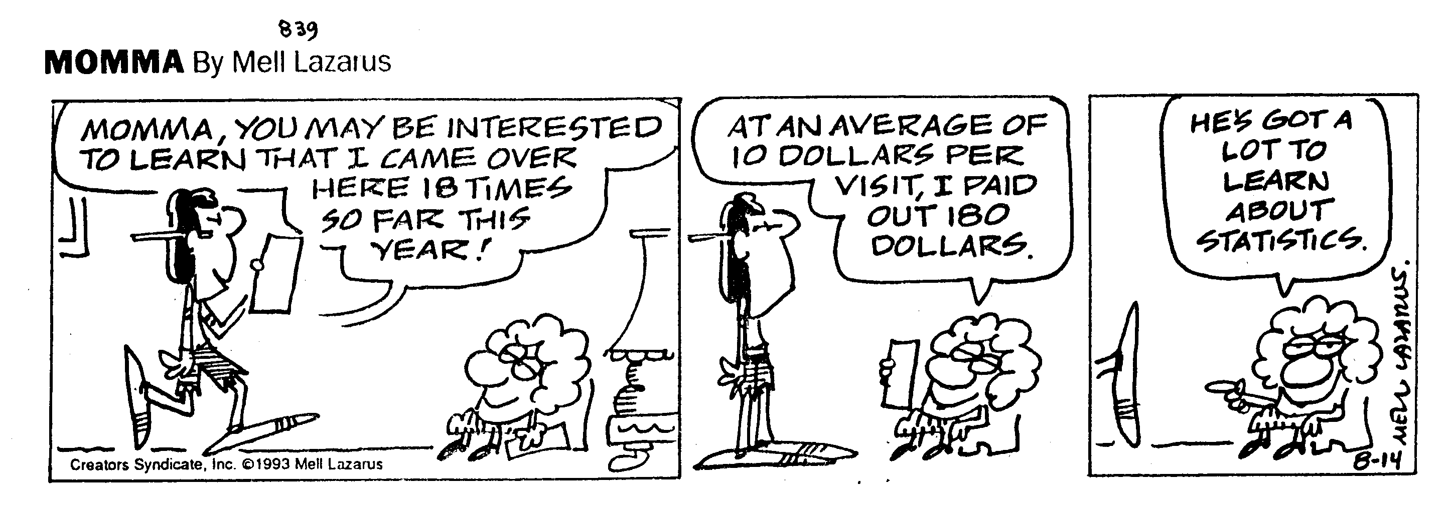

OPENING CARTOON
BIOS 150 – 18 NOVEMBER 2003
REGRESSION ANALYSIS #1

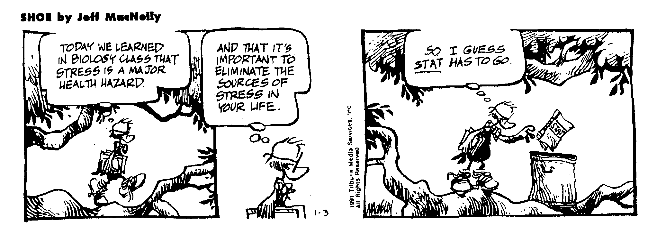

CLOSING CARTOON
BIOS 150 – 20 NOVEMBER 2003
REGRESSION ANALYSIS #2
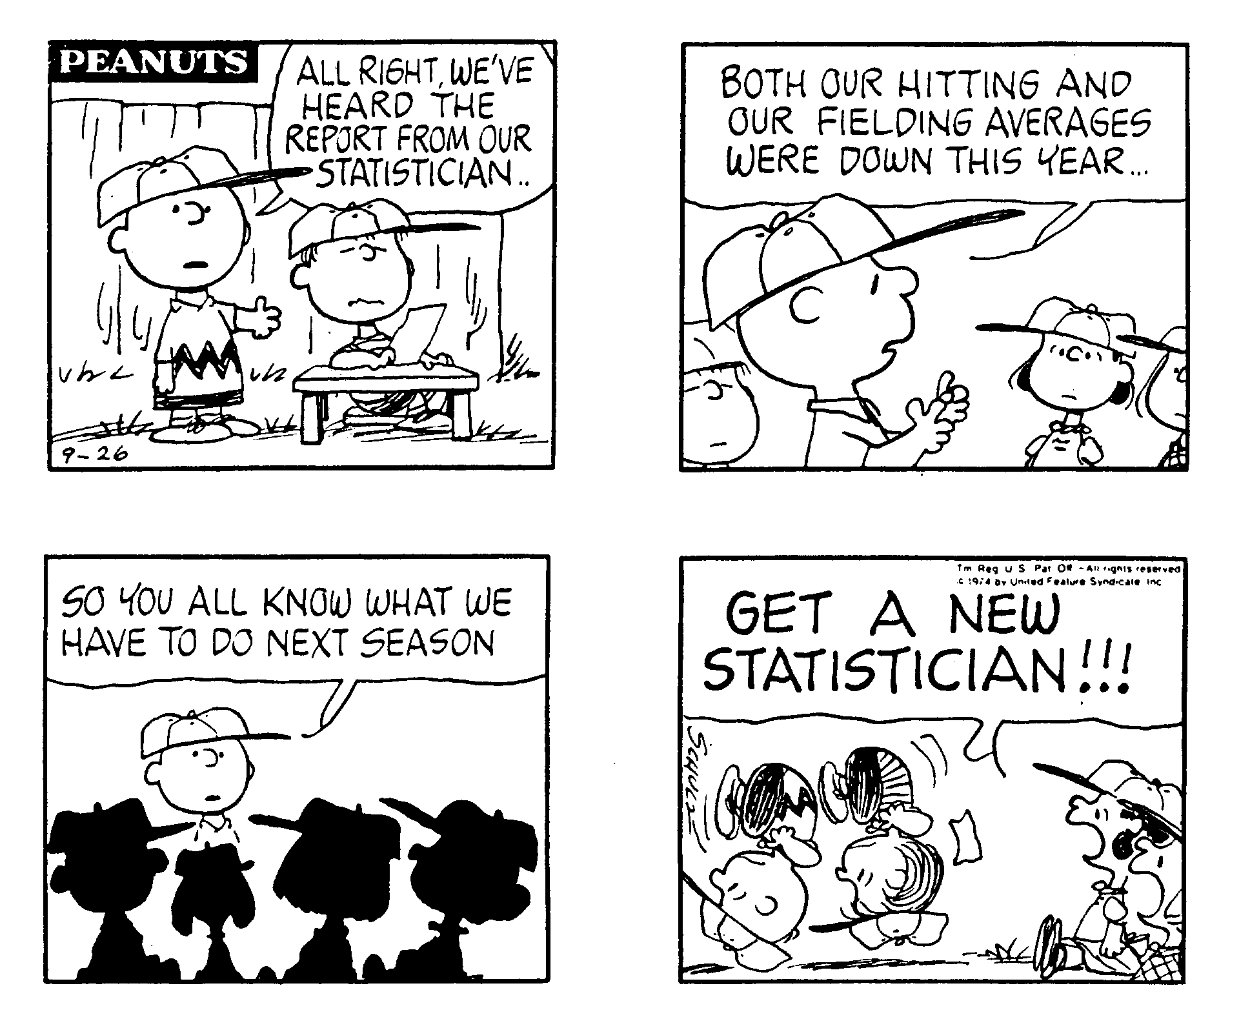
OPENING CARTOON
BIOS 150 – 20 NOVEMBER 2003
REGRESSION ANALYSIS #2

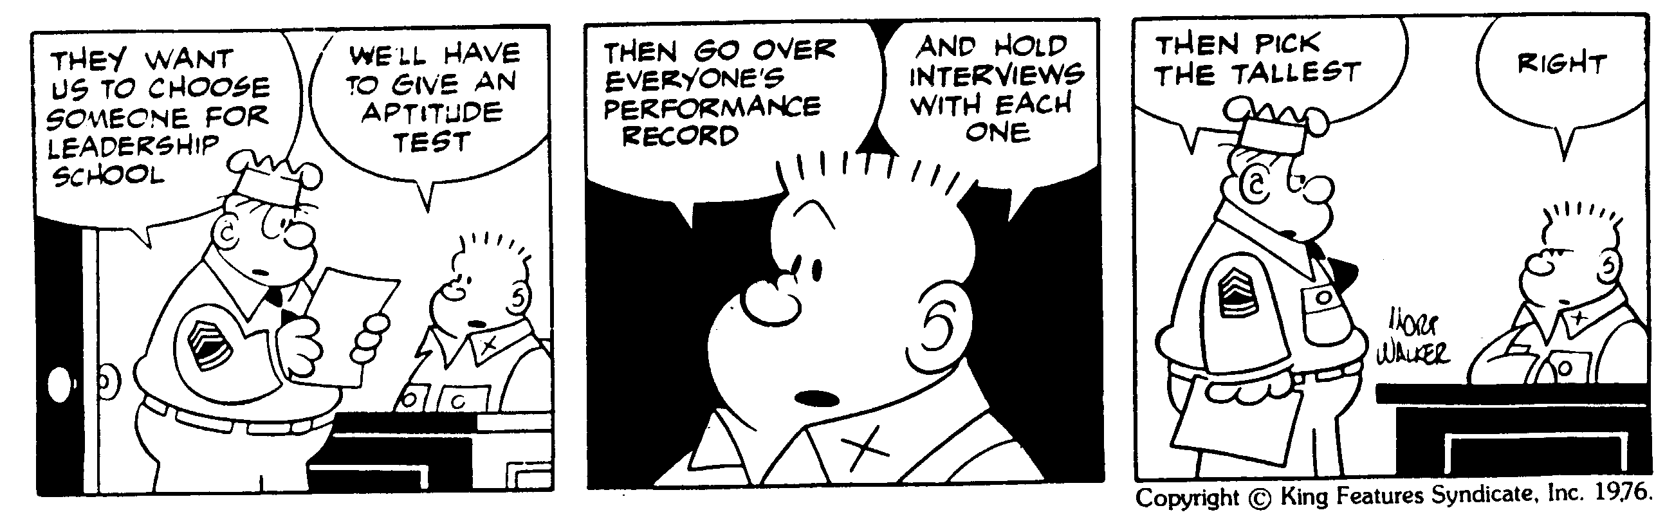
HOW STATISTICS IS REALLY USED

CLOSING CARTOON
BIOS 150 – 25 NOVEMBER 2003
REGRESSION ANALYSIS #3
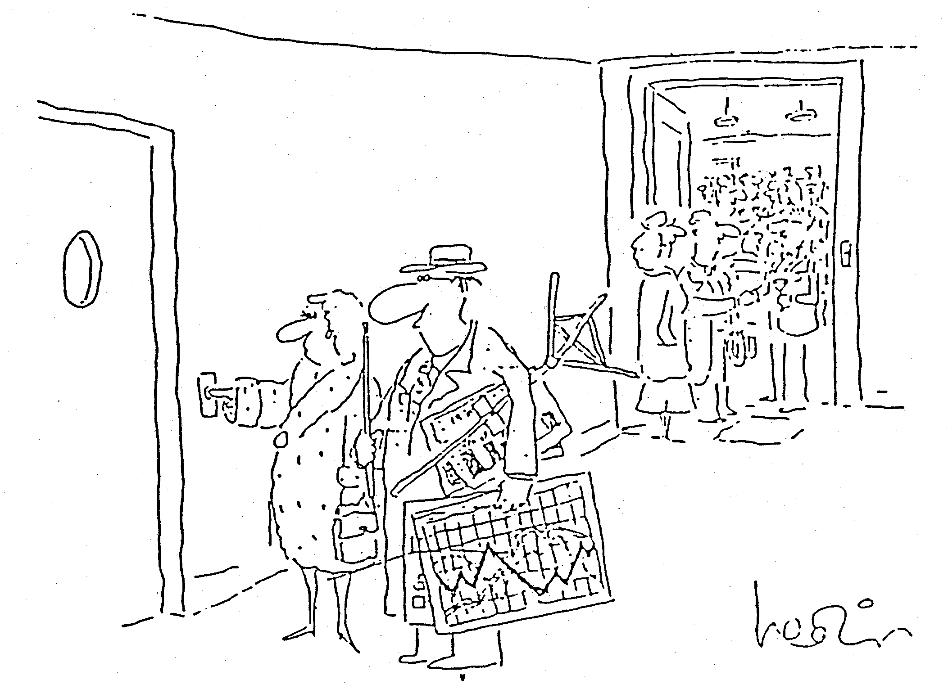
“Frankly, Quade, you’re beginning to bore everyone with your statistics.”

OPENING CARTOON
BIOS 150 – 25 NOVEMBER 2003
REGRESSION ANALYSIS #3

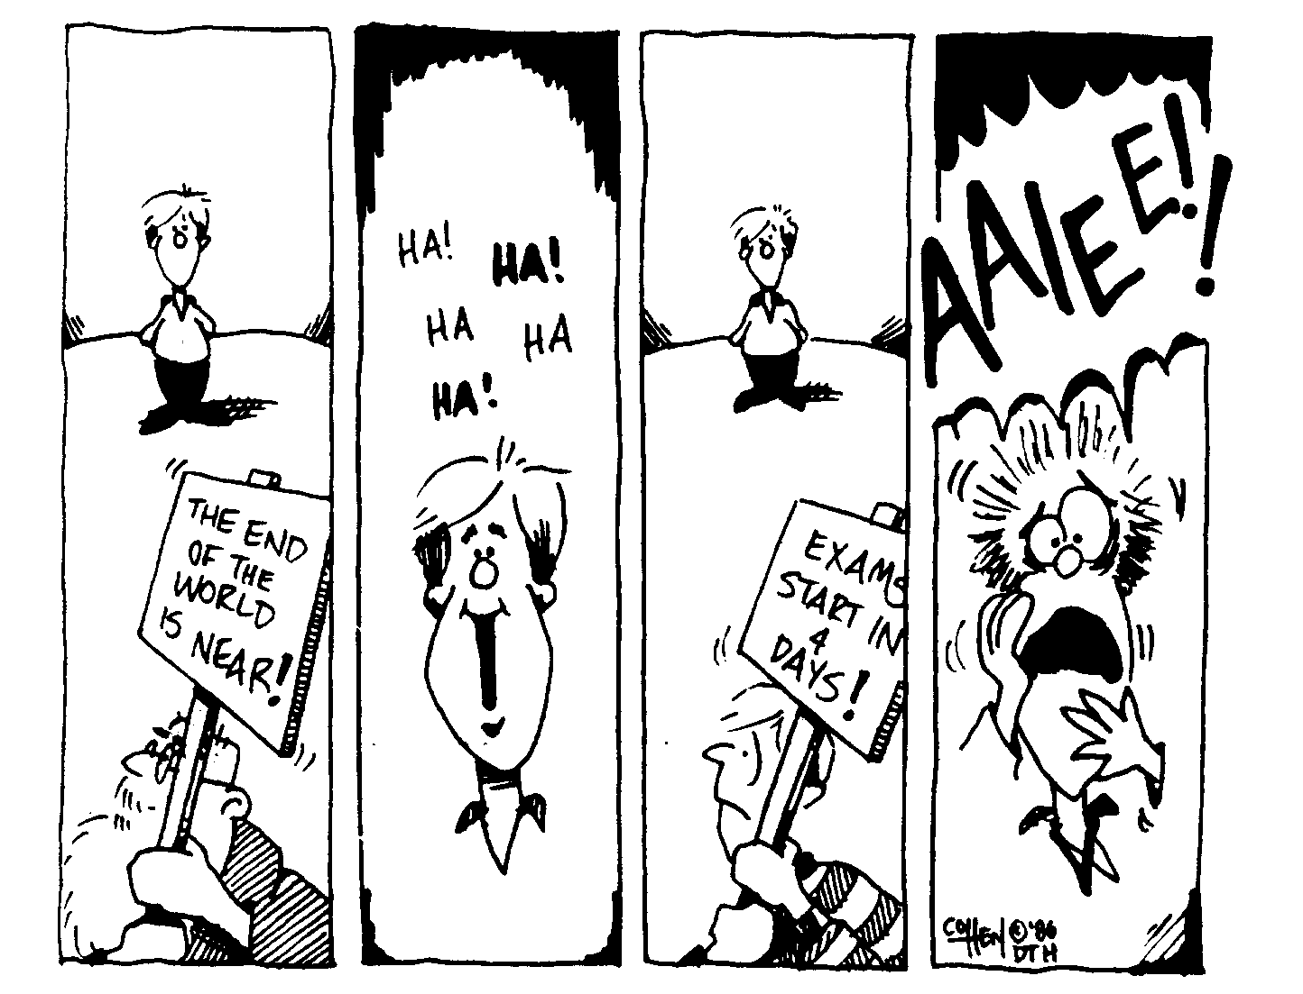

CLOSING CARTOON

